My Contact

yelinnhtet9598@gmail.com +959-252 482 969
Yangon, Myanmar
linkedin.com/in/ye-linn-htet

Skills

PHP, C#

Asp.Net MVC

.Net Core API

Entity Framework

HTML, CSS, JavaScript, TypeScript

Angular, Bootstrap

MySQL, MS SQL

Tools

Visual Studio Code

Visual Studio

Sublime Text

Postman

phpMyAdmin

SQL server Management Studio Git, Agile, Scrum

Education Background

University of Computer Studies, Magway Bachelor of Computer Science (B.C.Sc) Completed in November 2017

Languages

English

Myanmar
YE LINN HTET
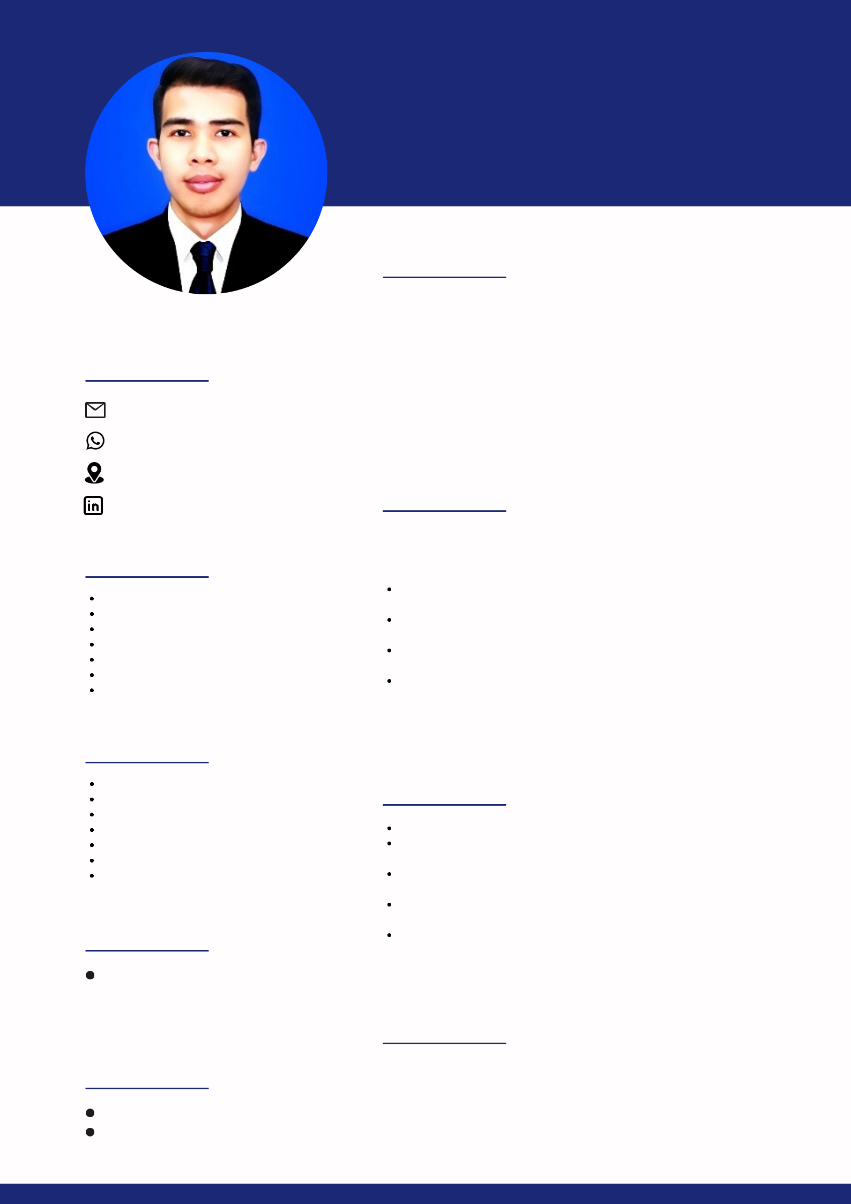

WEB DEVELOPER

About Me

Innovative and hardworking developer with four years of extensive hand on experience in designing and developing web applications from initial to final deliverable. Love learning new technologies and a quick learner. An experienced team player with excellent communication, interpersonal skills, and ability to work independently under pressure.

Professional Experience

Innovative Global Wave Technology Co. , Yangon

Web Developer September 2018 – February 2023

Key responsibilities:

Participated as an active developer and took responsibilities for both frontend and backend development

Developed e-government enterprise projects and supported customer training as required

Collaborated with other team members, project manager, quality assurance testers, and CTO as needed

Weekly project meeting with Business Development Executive Officer, Project Manager and Director, and discuss the features and requirements

Projects

Municipal Mobile App (Using C# .Net core API for backend)
Online Business License Registration and Administration System (Using Angular for frontend and PHP for backend)

Household Management System (Using Angular for frontend and PHP for backend)

Housing Management System (Using Angular for frontend and PHP for backend)

Property Taxation System (Using Angular for frontend and PHP for backend)

Career Interests

Expected Salary : SGD 3500 (Negotiable)

Position Finding : Permanent/ Contract (Min 2yrs)

Notice Period : 1 Month

